**SPEAKERS IN DR. MALAWER’S *INTERNATIONAL LAW CLASS* (Spring 2022)**

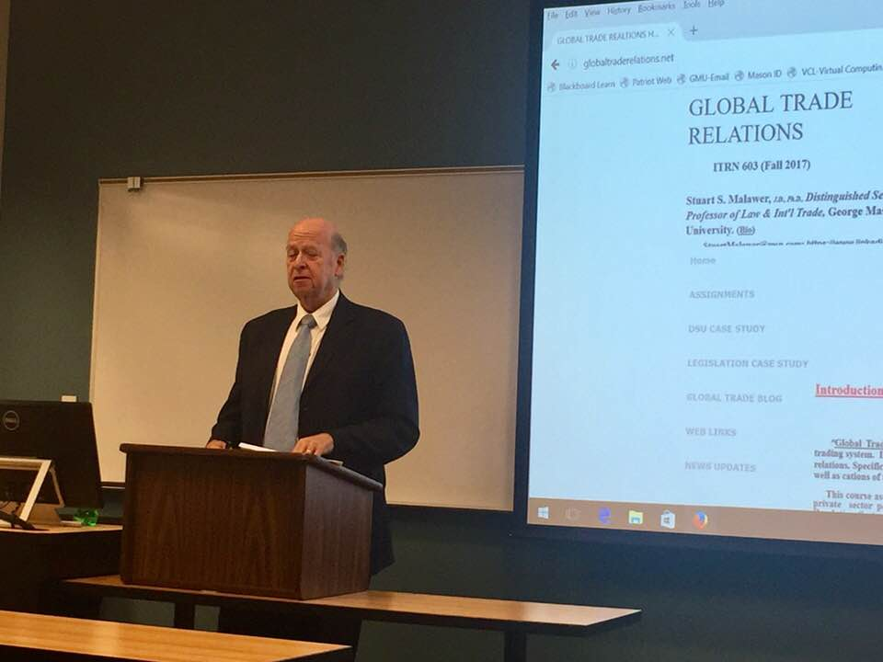

**Bart Fisher, J.D., Ph.D.. Author, “International Trade and Investment.”**

**Lawyer, investor, taught at Johns Hopkins (SAIS).**

***Lecture: “US - China Trade Relations -- Decoupling?”***

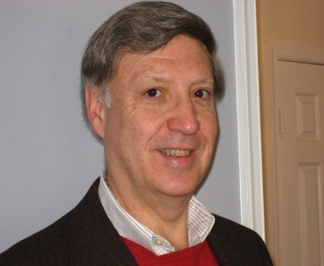

**Jeffrey Joseph. JD, MA. Former Vice President at the US Chamber of Commerce.**

***Lecture: “Risk Analysis and Trade: After Ukraine – Legal and Policy Issues.”***

**Todd Haymore. Former Secretary of Commerce and Trade & former**

**Secretary of Agriculture for the Commonwealth of Virginia. (Under**

**governors McDonnell and McAuliffe.)**

***Lecture: States in Global Trade and State Economic Development.”***

**Peter Watson. Former Chairman of the U.S. International Trade**

**Commission and former President and CEO of the Overseas Private**

**Investment Corporation. Also former member of the National Security Council (Asian Affairs).**

***Lecture: “National Security Considerations in U.S. Trade Policy Formulation.***